CONTENTS
TITLE
Product Overview
I.LCD screenParameters
II.MotherboardSpecifications
三, ProductFunction
四、Power Parameters
五、Environmental Factors
六、Random Accessories
七、Packaging and Weight
八、Dimensions

ProductOverview
This series of products belongs toWall-mounted network versionadvertising machine, the whole body is made of metal cold-rolled steel plate with spraying, aluminum alloy profiles for the edge strips, 4MM special tempered glass for the panel, high-definition effect, which can be widely used in building lobbies,Elevators,Hospitals, stations, hotels, subways, shopping malls, government buildings and other occasions are mainly used for multimedia information disclosure, picture advertising, text, audio and video media playback. It is a high-end digital signage advertising product.

1.LCD screenParameters
Effect picture
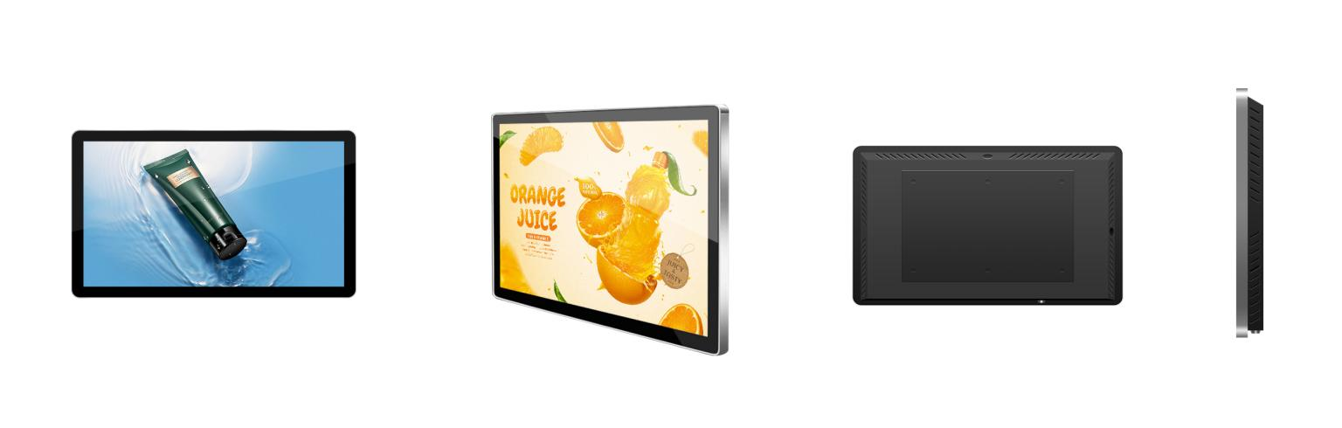
Product model | PH100D | PH133D | PH156D
Display size | 10.1 inch | 13.3 inch | 15.6 inch
Display ratio | （16：9）
Appearance color | Silver frame black body
Display type | LCD LCD screen
Picture display  size(H×V) mm | 216.58*135.36 | 293.76 *165.24 | 342.16 * 191.59
Physical resolution | 1280*800 | 1920*1080
Display color | 16.7M（8bit）
Refresh rate | 60Hz
Brightness | 250cd/m2
Contrast ratio | 1300:1
Viewing angle  (degrees) | 85/85/85/85 (Typ.)(CR≥10)
Display protection | 4mm fully tempered high explosion-proof glass
Backlight life | ＞50000 hours

2.MotherboardSpecifications
(Adapt the motherboard according to the parameters of the screen）
CPU | Quad-core ARM Cortex-A7, main frequency up to 1.2GHz
Memory | 1G DDR3
Storage | 8GB
Decoding resolution | Maximum support1080P@60fps
Audio and video output | Left and right channel output (2*10W speakers)
System upgrade | SupportUSB upgrade
USB interface | 2
RJ45 interface | 1

3.Product functions
Local operation functions
Network settings | Support wired and wireless network connections
Time-sharing settings | Support time-sharing setting of advertising machine power on and off time
Language switching | Support Simplified Chinese and English switching
Screen conversion | Support 0°, 90°, 180°, 270° screen switching
System upgrade | Support system background upgrade and local upgrade
USB | Support USB insertion to update programs
Background publishing system functions
Program management | Support setting the program list, you can delete, preview, publish and edit the program, and retransmit with one click
Program management | Support setting the program's playback schedule
Program management | Support setting the message list, you can delete, preview, and edit the message
Terminal management | Support terminal monitoring and terminal settings for selected terminals. Monitor the screen, view historical screenshots, view terminal storage programs, perform formatting operations on the terminal, and remote operation of the terminal
Message production | Support synchronously setting message content, message playback duration, and message playback time
Program production | Support synchronously setting program name, program content, program duration, playback type, and playback time

4.Power Parameters
Input power | 100-240V~50/60Hz
Overall power consumption | ≤25W | ≤30W | ≤35W | ≤45W | ≤55W
Standby power consumption | ≤0.5W

5.Environmental Factors
Operating temperature | 0℃~60℃
Operating humidity | 10%~75%RH
Storage temperature | 15℃~45℃
Storage humidity | 10%~90%RH
Altitude | Below 5000 meters

6.Random Accessories
Remote control | 1
Key | 1
Warranty card | 1
Certificate of conformity | 1

7.Packaging and Weight
Package size(cm) | 300*240*100 | 385*280*110mm | 450*310*110mm
净重（kg）
Gross weight（kg）
8.Dimensions
10.1 inch size chart | 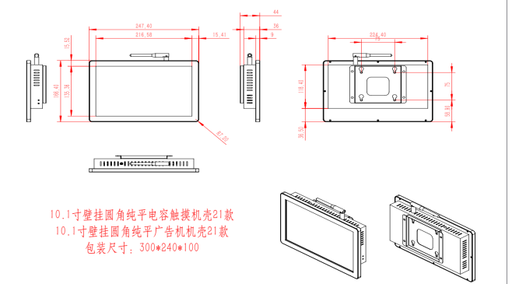
13.3 inch size chart | 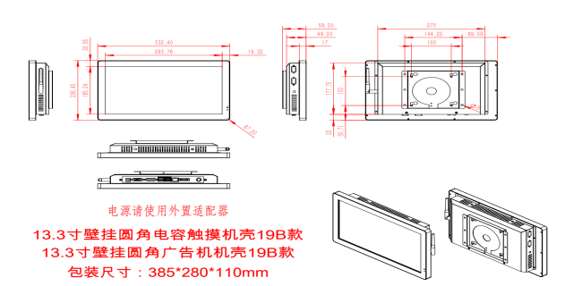
15.6 inch size chart | 