Contents (CONTENTS)
Title (TITLE)
Product Overview
1. LCD Screen Parameters
2. Mainboard Specifications
3. Product Functions
4. Power Supply Specifications
5. Environmental Factors
6. Included Accessories
7. Packaging and Weight
8. Dimensional Specifications

Product Overview
This series of products consists of wall-mounted network advertising displays, constructed with full-body cold-rolled steel plates coated by spraying, aluminum alloy profile edging, and a 4mm specialized tempered glass panel, offering high-definition display quality. They are widely applicable in building lobbies, elevators, hospitals, stations, hotels, subways, shopping malls, government buildings, and similar environments. Primarily designed for multimedia information display, image advertising, text, and audio-video playback, this is a high-end digital signage advertising product.

1. LCD Screen Parameters
Rendering
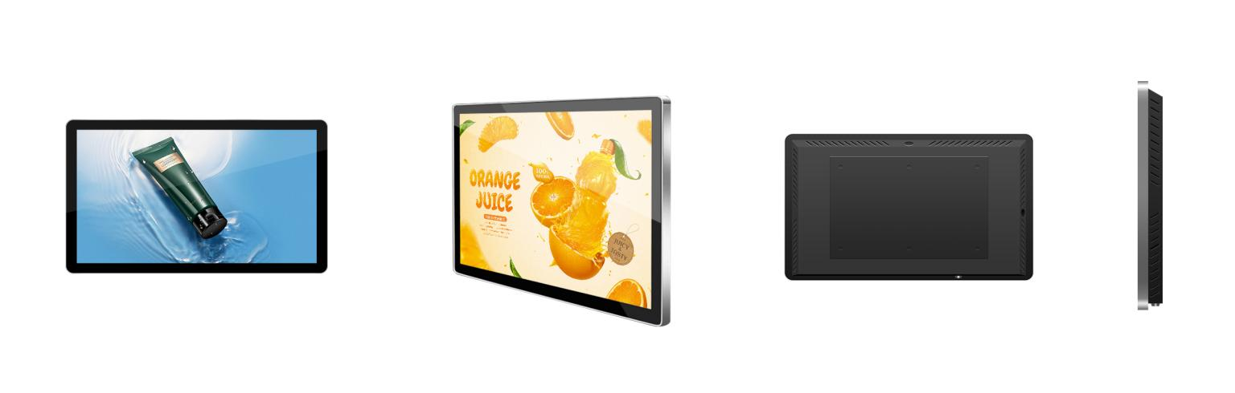
Product Model | PH185D | PH195D | PH215D | PH240D | PH270D
Display Size | 18.5 inches | 19.5 inches | 21.5 inches | 24 inches | 27 inches
Aspect Ratio | （16：9）
Appearance Color | Silver Frame with Black Housing
Display Type | LCD Liquid Crystal Display
Active Display Area (H×V) mm | 409*230 | 432.5*235.5 | 476*268 | 522*294 | 622.5*343
Physical Resolution | 1366*768 | 1920*1080
Display Colors | 16.7M（8bit）
Refresh Rate | 60Hz
Brightness | 250cd/m2
Contrast | 1000:1 | 1000:1 | 1000:1 | 1000:1 | 1000:1
Viewing Angle (°) | 89/89/89/89 (Typ.)(CR≥10)
Display Protection | 4mm Fully Tempered, High Explosion-Resistance Glass
Backlight Life | >50,000 hours

2. Mainboard Specifications
CPU | Quad-core ARM Cortex-A7, operating frequency up to 1.2 GHz
Memory | 1G DDR3
Storage | 8GB
Decoding Resolution | Maximum support: 1080P@60fps
Audio/Video Output | Stereo output (2 × 10W speakers)
System Upgrade | Supports USB-based upgrades
USB Ports | 2 ports
RJ45 Interface | 1 unit

3. Product Functions
Local Operation Functions
Network Settings | Supports both wired and wireless network connections
Time-sharing Settings | Supports time-sharing configuration for advertising device power on/off intervals
Language Switching | Supports switching between Simplified Chinese and English
Screen Rotation | Supports screen rotation at 0°, 90°, 180°, and 270°
USB | Supports USB insertion for program updates
Backend Publishing System Functions
Program Management | Supports configuration of program lists with options to delete, preview, publish, edit, and one-click retransmission
Program Management | Supports scheduling of program playback
Program Management | Supports configuration of message lists with options to delete, preview, and edit messages
Terminal Management | Supports terminal monitoring and configuration for selected terminals. Monitoring screen, viewing historical screenshots, accessing terminal-stored programs, performing terminal formatting operations, and remote terminal control.
Message Creation | Supports synchronized configuration of message content, playback duration, and playback schedule.
Program Creation | Supports synchronized configuration of program name, content, duration, playback type, and playback schedule.

4. Power Supply Specifications
Input Power | 100-240V~50/60Hz
Total Power Consumption | ≤25W | ≤30W | ≤35W | ≤45W | ≤55W
Standby Power Consumption | ≤0.5W

5. Environmental Factors
Operating Temperature | 0℃~60℃
Operating Humidity | 10%~75%RH
Storage Temperature | 15℃~45℃
Storage Humidity | 10%~90%RH
Altitude | Below 5000 meters

6. Included Accessories
Remote Control | 1 unit
Key | 1 piece
Warranty Card | 1 sheet
Certificate of Conformity | 1 sheet

7.Packaging and Weight
Packaging Dimensions (cm) | 57*11.5*38 | 57*11.5*38 | 62*11*42 | 68*11*45 | 76*12.5*55
Net Weight (kg) | 5.2 | 5.8 | 6.2 | 7.5 | 9.5
Gross Weight (kg) | 6 | 6.5 | 8 | 8.6 | 11

8. Dimensional Specifications
18.5-inch Dimensional Drawing | 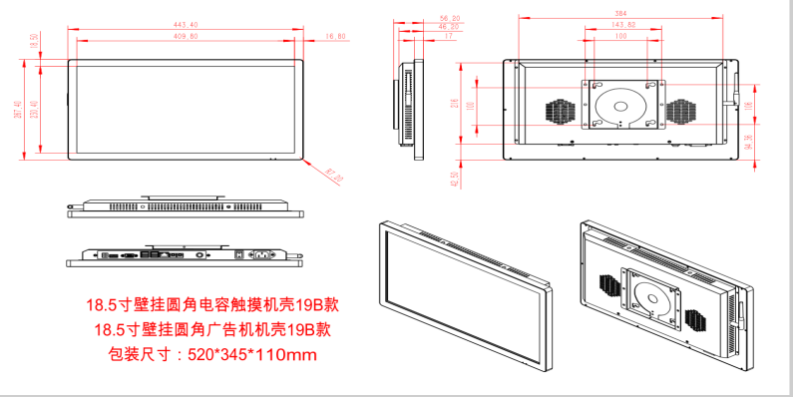
21.5-inch Dimensional Drawing | 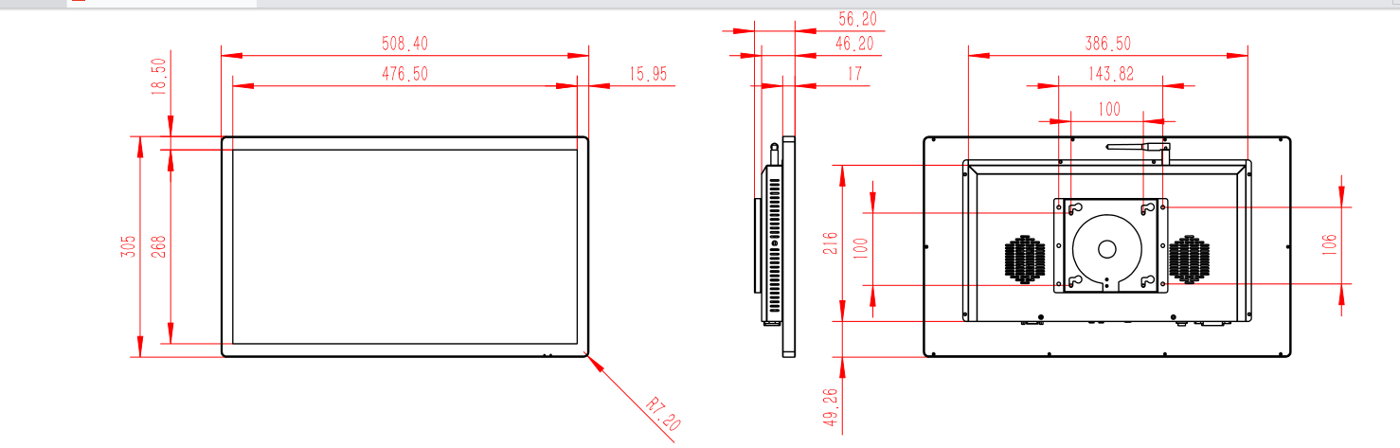
24-inch Dimensional Drawing | 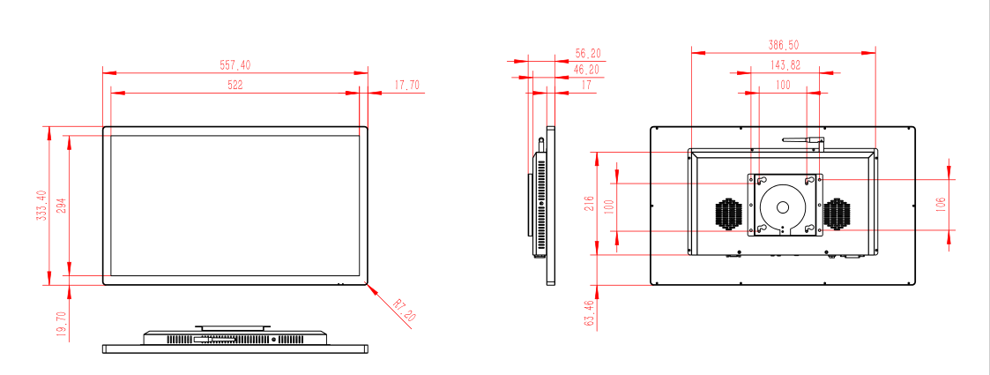
27-inch Dimensional Drawing | 