Contents (CONTENTS)
Title (TITLE)
Product Overview
1. LCD Screen Parameters
2. Motherboard Specifications
3. Product Functions
4. Power Supply Parameters
5. Environmental Factors
6. Standard Accessories
7. Packaging and Weight
8. Dimensional Specifications

Product Overview
This series of products belongs to the wall-mounted network advertising machine category, comprising a full metal body made of cold-rolled steel sheet with spray coating, bezel aluminum alloy profile, and a 4 mm special tempered glass panel. It provides high-definition performance and is widely applicable in building lobbies, hospitals, stations, hotels, subway stations, shopping malls, government buildings, and other venues. It is primarily designed for multimedia information display, image advertising, text, audio, and video media playback, constituting a high-end digital signage advertising product.

1. LCD Screen Parameters
Rendering
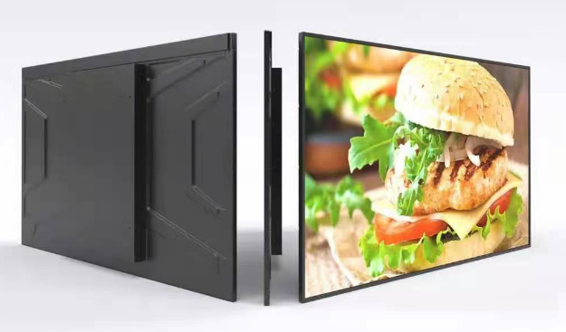
Product Model | BH320D | BH430D |  | BH490D |  | BH550D | BH650D
Display Size | 32 inches | 43 inches |  | 50 inches |  | 55 inches | 65 inches
Aspect Ratio | （16：9）
Color | Black Bezel with Black Chassis
Display Type | LCD Panel
Display Area (H × V) mm | 697.6*392.2 | 939.8*527.5 |  | 1094.4*614 |  | 1210.1*680.5 | 1430*805
Physical Resolution | 1920（H）×1080（V）
Color Depth | 16.7M（8bit）
Refresh Rate | 60Hz
Brightness | 350cd/m2
Contrast | 1200：1 |  | 1200:1 |  | 5000:1 | 1200:1 | 1200:1
Viewing Angle (°) | 89/89/89/89 (Typ.)(CR≥10)
Display Protection | 4mm Fully Tempered High Explosion-Proof Glass
Backlight Lifespan | >50,000 Hours

2. Motherboard Specifications
Mainboard Model | Grayscale HD-A133M | Grayscale HD-972S
CPU | Allwinner A133, Quad-Core, Maximum Frequency up to 1.6 GHz | T972, Quad-Core, Maximum Frequency up to 1.9 GHz
Operating System | Android OS 10.0 | Android OS 9.0
Memory | 1G | 2G
Storage | 8GB | 32GB
Audio and Video Output | Left and right channel output (2×10W/8Ω)
System upgrade | Supports USB upgrade
USB interface | 2 units
RJ45 interface | 1 unit

3. Product Functions
Local operation functions
Network settings | Supports both wired and wireless network connections
Time-sharing settings | Supports time-sharing settings for advertising machine power on/off time periods
Language switching | Supports switching between Simplified Chinese and English
Screen rotation | Supports 0°, 90°, 180°, and 270° screen rotation
USB | Supports USB plug-in program updates
Background Publishing System Functions
Program Management | Supports configuring program lists, enabling deletion, preview, publishing, editing, and one-click retransmission of programs
Program Management | Supports scheduling program playback
Program Management | Supports configuring message lists, enabling deletion, preview, and editing of messages
Terminal Management | Supports monitoring and configuring selected terminalsMonitors screens, views historical screenshots, accesses programs stored on terminals, performs terminal formatting, and executes remote terminal operations
Message Creation | Supports synchronous configuration of message content, playback duration, and playback schedule
Program Creation | Supports synchronous configuration of program name, content, duration, playback type, and playback schedule

4. Power Supply Parameters
Input Power | 100-240V~50/60Hz
Display Size | 32 inches | 43 inches | 50 inches | 55 inches | 65 inches
Total Power Consumption | ≤30W | ≤45W | ≤65W | ≤75W | ≤75W
Standby Power Consumption | ≤1.5W

5. Environmental Factors
Operating Temperature | 0℃~60℃
Operating Humidity | 10%~75%RH
Storage Temperature | 15℃~45℃
Storage Humidity | 10%~90%RH
Altitude | Below 5000 m

6. Standard Accessories
Remote Control | 1 unit
Key | 1 piece
Warranty Card | 1 sheet
Certificate of Conformity | 1 sheet

7.Packaging and Weight
Display Size | 32 inches | 43 inches | 50 inches | 55 inches | 65 inches
Package Dimensions (cm) | 83*16*55.5 | 110*16*70 | 121*16*78 | 134*16*84 | 158*14.7*97.5
Gross Weight (kg) | 12 | 18 | 24 | 28 | 43

8.Dimension Specifications

32-inch Dimension Drawing | 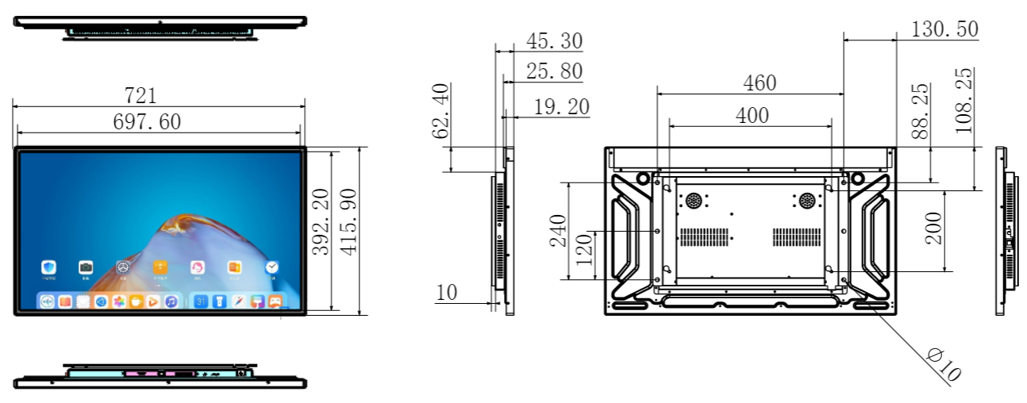
43-inch Dimension Drawing | 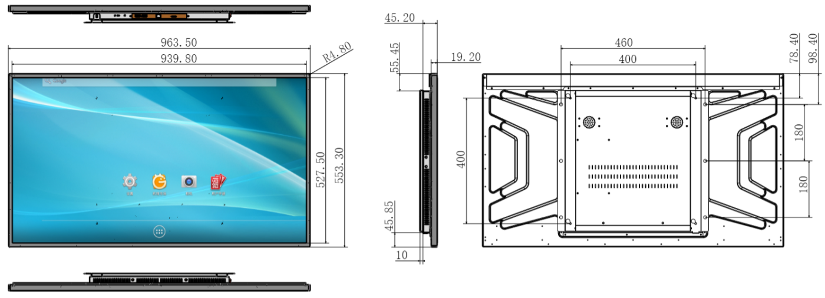
50-inch Dimension Drawing | 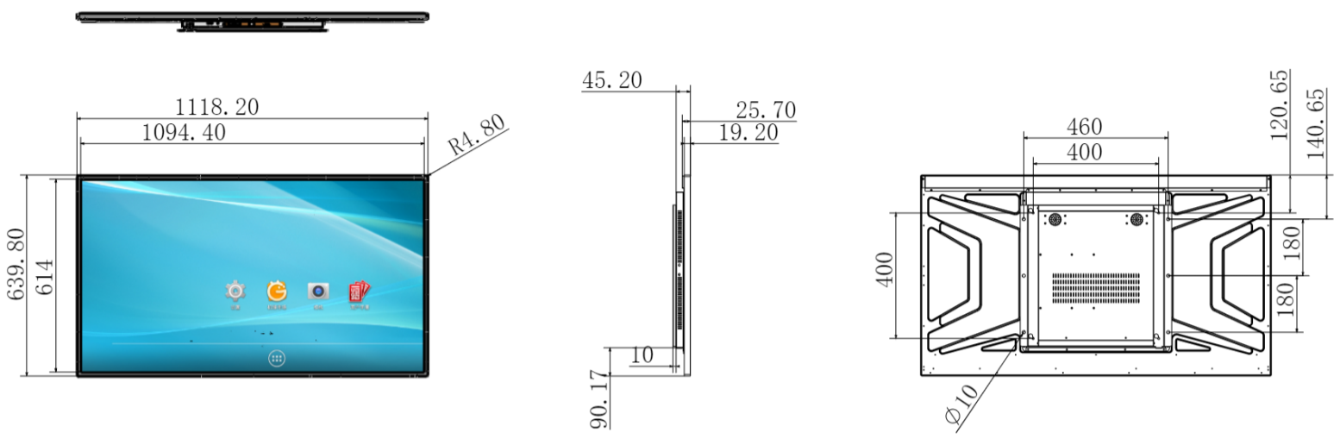
55-inch Dimension Drawing | 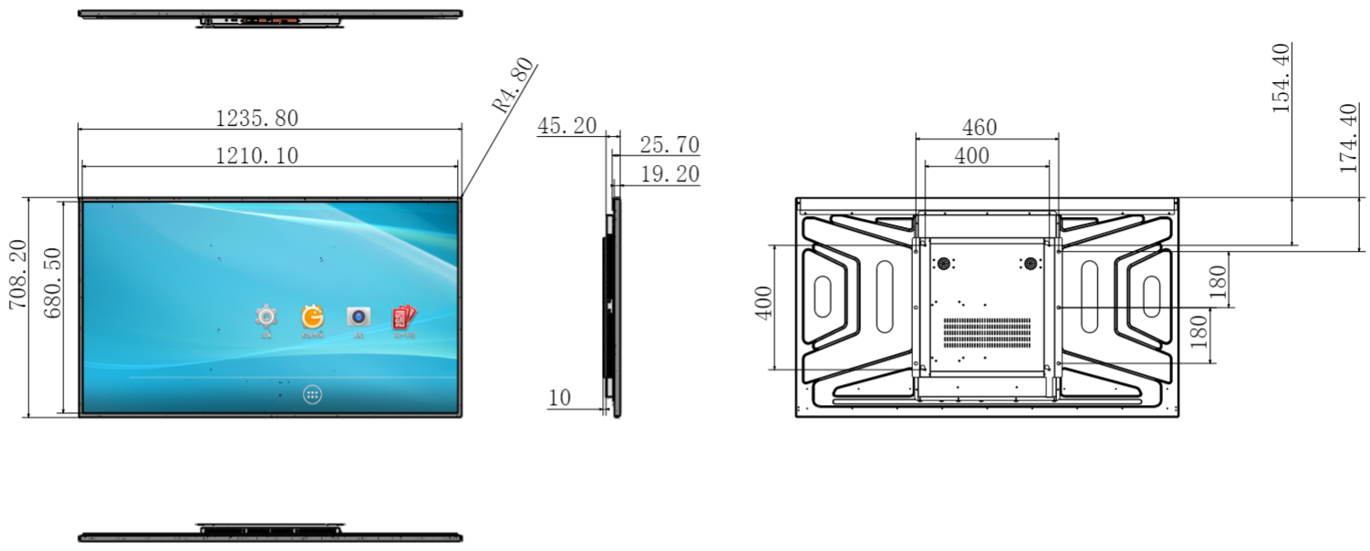
65-inch Dimension Drawing | 