98-inch H1 infrared touch teaching all-in-one interactive smart flat panel display specifications
Specification and model:YZ-.H1.-98 Page number:Sequence1Page Share4Page
Effect drawing
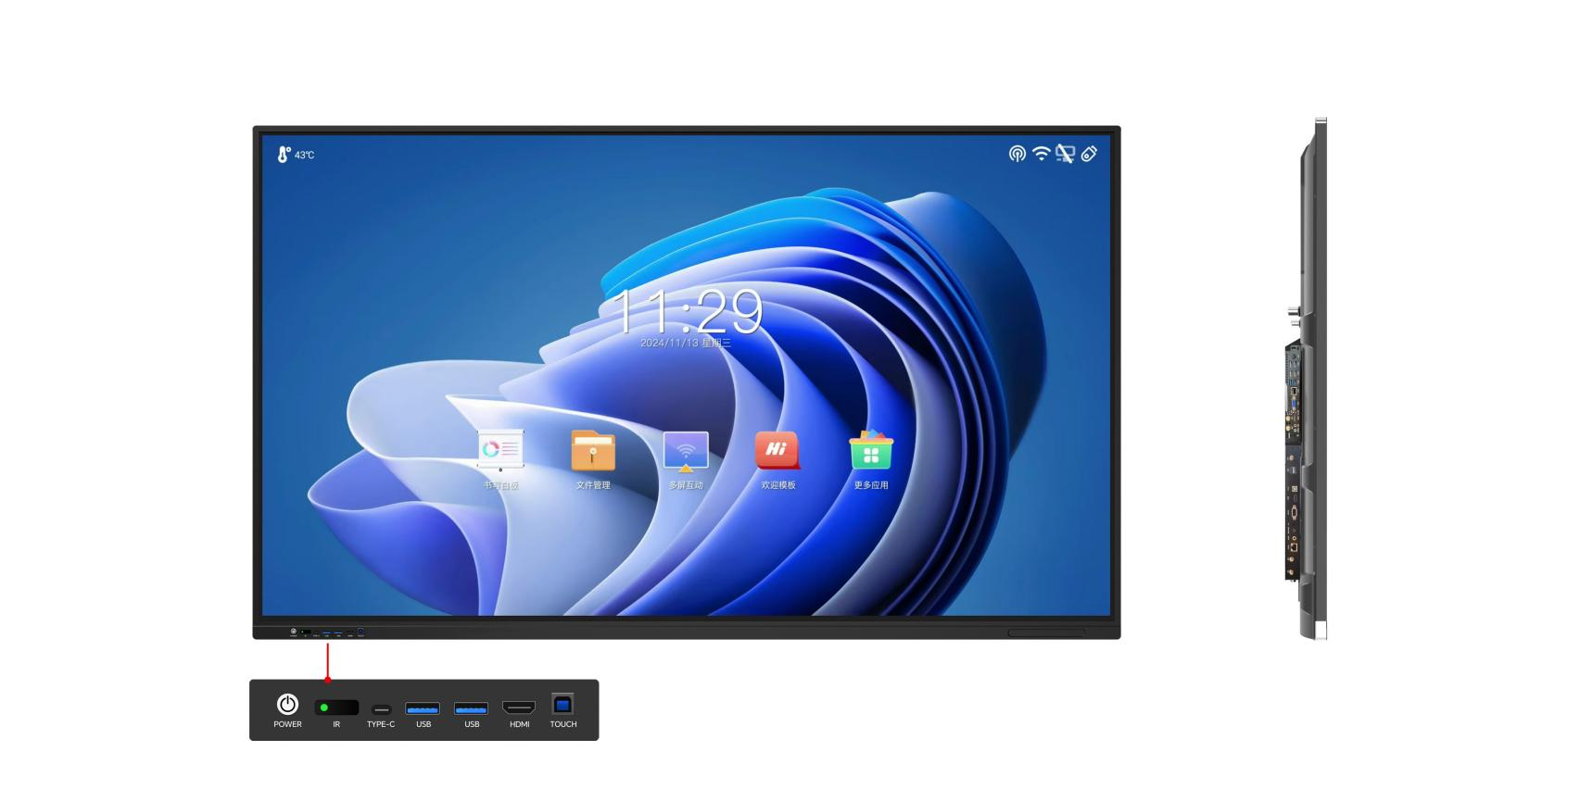
Design instructions
- Ultra-thin Aluminium Move forward Frame, surface spray Fine Sand and anodizing,Zinc alloy electroplating angle code, sheet metal Back cover,The whole machine has a super metal texture and Active heat dissipation;
- Tempered glass, protect liquid crystal glass and.Enhance the visual effects,Protect your viewing eyesight and Improve the touch experience;
- Touch constant:
1.Touch accuracy Positive or negative 1Mm; 2-Support 2 branches;
2.Three Mm pen tip writing at the same time;
3.Support 56Mm pen tip to write at the same time;
4.Support multiple people to write small characters within 1cm high;
5.100% double-color pen recognition accuracy; (requires the support of Android whiteboard software)
6.pen height <1mm,Write foreign characters without continuous strokes (meet the standards of UNESCO supplier Promethean);
- The full series of structural zero-sticking and low-touch technology, with a strong touch writing experience;
- Operating system: Android and Windows (optional);
- The speaker is front-mounted to prevent the sound effect from deteriorating due to the embedded environment.;
- Using the international general standard OPS slot, the integrated plug-in design is convenient for upgrading and maintenance. There is no visible connection cable of the computer module on the outside, and the body is beautiful.;
- Support gesture side-pull menu, the menu can quickly adjust the brightness and sound, and switch the signal source.;
- Straight-down module backlight, mature, stable and extremely durable;
- Support WIFI wireless connection and network port wired connection;
- The system comes with screen projection, electronic whiteboard, annotation and other functions;
- FRONT EXPANSION PORT: 2 USB, 1 HDMI INPUT, 1 TYPE-C, 1 TOUCH USB IS CONVENIENT FOR USERS TO USE EXTERNAL DEVICES;
- Support multi-touch screen. When using a PC motherboard as a dual-system all-in-one machine, the touch box can be seamlessly switched between dual systems (windows/Android);
- Android 13.0 system support, multi-theme system setting and switching at any time, power-on LOGO setting customization and other functions;
- Support Android arbitrary picture handwriting annotation function, support real-scene annotation and panoramic writing annotation function. Support gestures Side Pull the navigation bar to call out common function shortcuts with one click.;

Specification and model:YZ-.H1.-98 Page number:Sequence2Page Share4Page
Display parameters | Screen size |  | 98"LED screen (16:9):2157.9Unknown 1213.35Mm [HxV]
Display parameters | Screen brand |  | Original brand-new ultra-clear LED screen
Display parameters | .Resolution |  | 3840 (H)×2160 (V)
Display parameters | Viewing angle |  | 178 degree(H):178 degree(V)
Display parameters | Brightness |  | Three50cd/m2
Display parameters | Contrast |  | 5000: 1
Display parameters | Response time |  | 8Master of Science
Display parameters | Color depth |  | 16.7M
Display parameters | Scanning frequency |  | 4K-30HZ
Display parameters | Backlight |  | Dimension Large electronic display
Display parameters | Display output |  | HDMI.
Display parameters | Color system |  | PAL, NTSC
Display parameters | Sound |  | 3D stereo sound effect Output power 2*10W
Display parameters | Display protection |  | Anti-glare tempered Glass
Touch parameters | .Touch embedding method |  | Built-in all-in-one, non-plug-in
Touch parameters | Touch sensing technology |  | Infrared induction recognition touch technology (20 o'clock)
Touch parameters | The way of writing |  | Fingers, touch pens or other diameters not less than2Mm non-transparent objects
Touch parameters | The cursor speed |  | 120 points/s
Touch parameters | Positioning accuracy |  | More than 90% of the touch areas are±2mm
Touch parameters | Communication interface |  | B-type USB male
Touch parameters | Touch resolution |  | 32767*32767
Touch parameters | The number of touches |  | The theory is infinite.
Touch parameters | Computer response |  | Automatic recognition by the system;≤15 ms
Touch parameters | Driver |  | Free to drive
Touch parameters | Touch function |  | Hold out20 o'clock computer touch operation.,Support image enlargement, reduction and rotation
Parameters of the whole machine | Mainboard system |  | Android 1Three.0
Parameters of the whole machine | Motherboard processor |  | Quad core ARMCortex-A55
Parameters of the whole machine | Motherboard Storage space |  | 32 G
Parameters of the whole machine | Motherboard Internal storage |  | 4Generation
Parameters of the whole machine | Input port |  | RJ 45Network port: 1 group/HDMI IN interface: one set/USB: two sets/AV IN: two sets
Parameters of the whole machine | Output port |  | AV OUT: TWO GROUPS/COAX OUT: ONE GROUP/RS232: ONE GROUP/TOUCH OUT: ONE GROUP/ERP OUT: ONE GROUP
Parameters of the whole machine | Front port |  | Universal serial busX2, HDMI IN, TOUCH USB., TYPE-C
Parameters of the whole machine | Storage environment |  | Storage temperature: -20℃~60.℃; Storage humidity: 10%RH~90%RH
Parameters of the whole machine | Working environment |  | Working temperature: -10℃~55.℃; Working humidity: 10%RH~90%RH
Parameters of the whole machine | Installation method |  | Hanging rack (standard configuration)
Parameters of the whole machine | Hanger hole spacing |  | .1000×400 MM
Parameters of the whole machine | Power supply type/mode |  | Three-core power supply/fixed
Parameters of the whole machine | Power interface specifications |  | Character seat
Parameters of the whole machine | Power consumption |  | Weigh590Tile(Does not include the host)
Parameters of the whole machine | Voltage range |  | 110~240V/50~60Hz
Parameters of the whole machine | Sound |  | Move forward Set 2 8∩10W mid-tone speaker
Parameters of the whole machine | Installation size of embedded wall |  | 2217.4*13.04.8*10.5.2
Parameters of the whole machine | Principles of wall installation |  | One-sided enlargement 20mm
Parameters of the whole machine | .Standby power consumption |  | ≦0.5 W
Parameters of the whole machine | Service life |  | ≧50,000 hours
Specification and model:YZ-.H1.-98 Page number:Sequence Three Page Share4Page
Computer configuration | Middle configuration/i3 configuration |  |  | High configuration/i5 configuration | Tall Configuration/i7 configuration
Computer configuration | Intel chipset
Computer configuration | Intel Core i3-2 generation/4th generation |  |  | Intel Core i5-2 generation/4th generation | Intel Core i7-2 generation/4th generation
Computer configuration | .4th generation DDR3 memory/2.5-inch 128G hard disk |  |  | 4G DDR3 memory/2.5-inch 128G hard disk | 4G DDR3 memory/2.5-inch 128G hard disk
Computer configuration | Intel core graphics card Intel HD Graphics |  |  | Intel core graphics card Intel HD Graphics | Intel core graphics card Intel HD Graphics
Computer configuration | Input port | .1*LAN port, 3*USB3.0 port, 3*USB2.0 port, 1*MIC-IN port
Computer configuration | Output port | 1*HDMI PORT, 1*VGA PORT, 1*LINE-OUT PORT
Computer configuration | Operating system | Windows 7 Ultimate Operating System(Win 10Operating system Optional)
Random attachments | Standard random accessories: touch pen, warranty card, qualification certificate, instruction manual, remote control, 1.5-meter power cord
Dimensional drawing of the whole machine
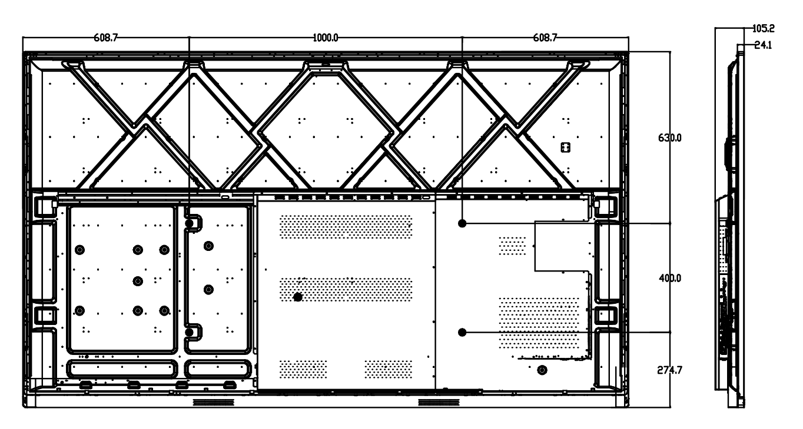
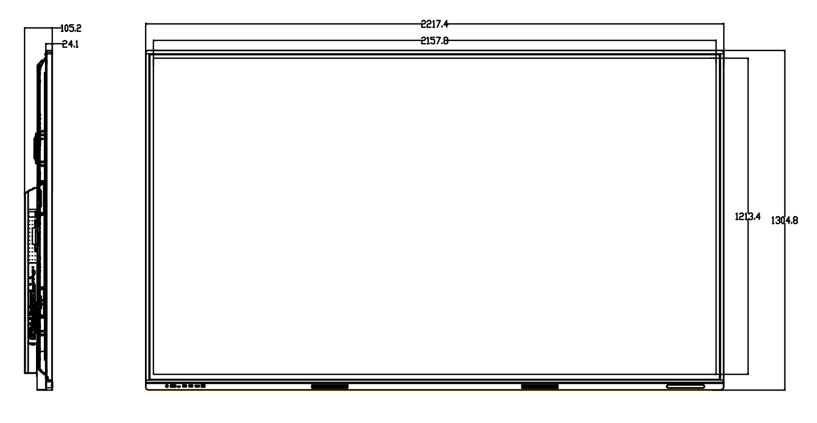

Specification and model:YZ-.H1.-98 Page number:Sequence4Page Share4Page
.Often applicable industry chart

